Tab 1
Terraform as a Resource provider (RP) on Azure

Pre-read - Call notes between Brandon & Armon on 11th Dec. 2025.
Context - Services listing on Azure portal NOT Azure Marketplace.
Microsoft partner facing content.

Approach | RPaaS (Azure Portal) | Hybrid 1P / Resell | Full 1P
Examples | Oracle DB @ Azure | Anyscale (Private Preview) | Azure Databricks, RedHat OpenShift, Enterprise Linux
Engineering Ownership (Porting) | Partner (or via Lifter program*) | Partner (same as RPaaS) | Microsoft
Intellectual Property (IP) | Partner | Partner | Shared with Microsoft
UI/UX | Partner flexibility, 'Partner' badge if using Lifter. | Partner flexibility. | Azure Native Experience.
Security, policy & Compliance | Partner standards | Partner standards | Microsoft standards
Hosting Location | Flexible | Flexible (commercial restrictions may apply) | Azure Native (MS production tenant)
Billing Engine | Partner Center | Partner Center | 1P Microsoft Billing
Quota Retirement (MS sales) | <50% | 100% | 100%
MACC (customer) | Partial-Full | Full | Full
Commercials/Pricing | Partner owns terms/pricing | MS resells; MS owns terms/pricing | Microsoft owns terms/pricing
Customer Agreements | Partner Agreement | Partner & Microsoft Agreements | Microsoft Agreement
Customer Support | Joint Support (MS primary, triages to partner) | Joint Support (MS primary, triages to partner) | Microsoft (backend by partner)
Support Agreement | Not Required | Required | Microsoft manages
Timelines (estimated  Contract - GA) | 3-6months | ~6months | 2yrs

Technical exploration -
Github repo (requires invitation from Evan).
Building first RP (private) repo.
RP extensions contract.
Draft list of areas of dev work needed -
- Develop the RP API and author TypeSpec to ensure compliance with the common RP contract.
- Onboard the terraform RP service to use some Azure mandatory services including AAD, Azure Monitor, and billing.
- Design and implement a declarative Portal Extension for native user experience and resource creation.
- Create a private SaaS offer, define billing meters, and publish the final product on Marketplace for testing & review.

Reference Azure portal screenshots
Reference Azure portal screenshots

RPaaS example -
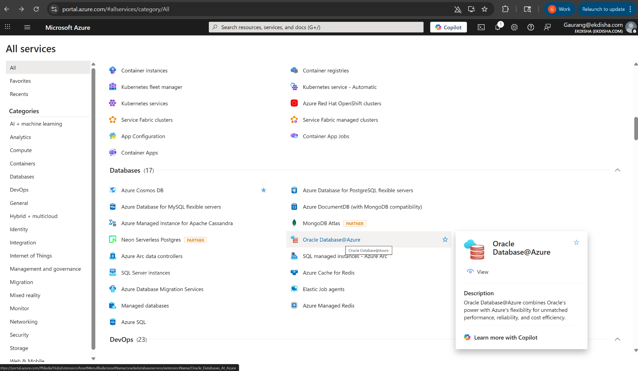

Partner label through lifter program (RPaaS model) -
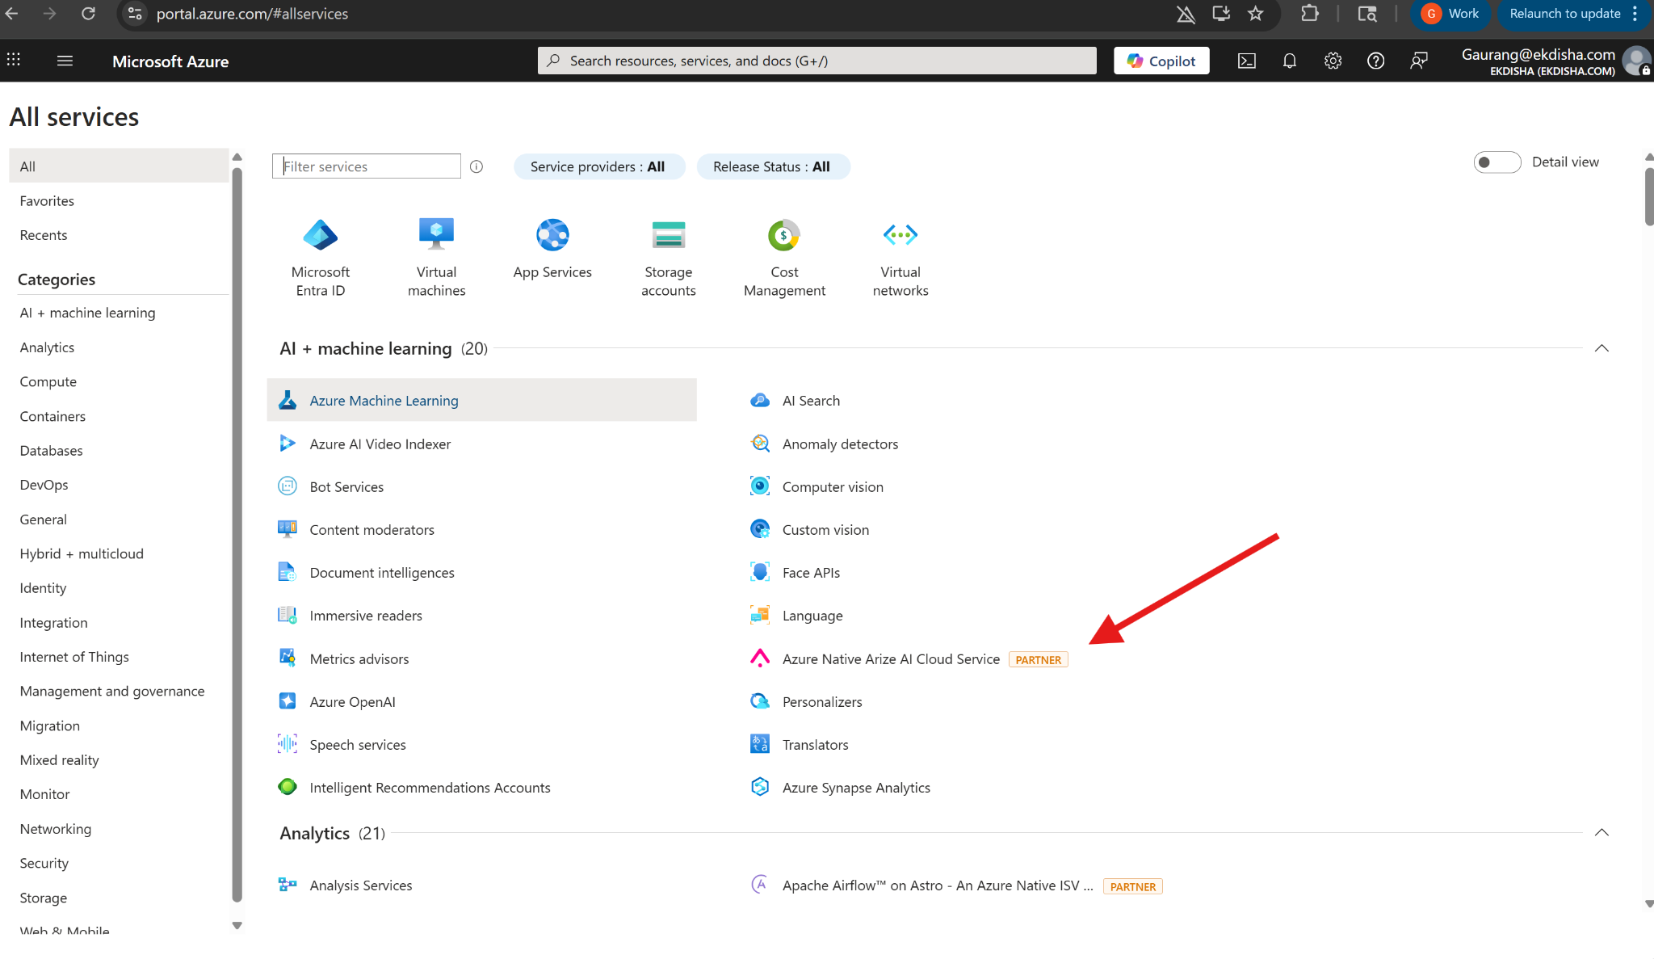

Full 1P example -
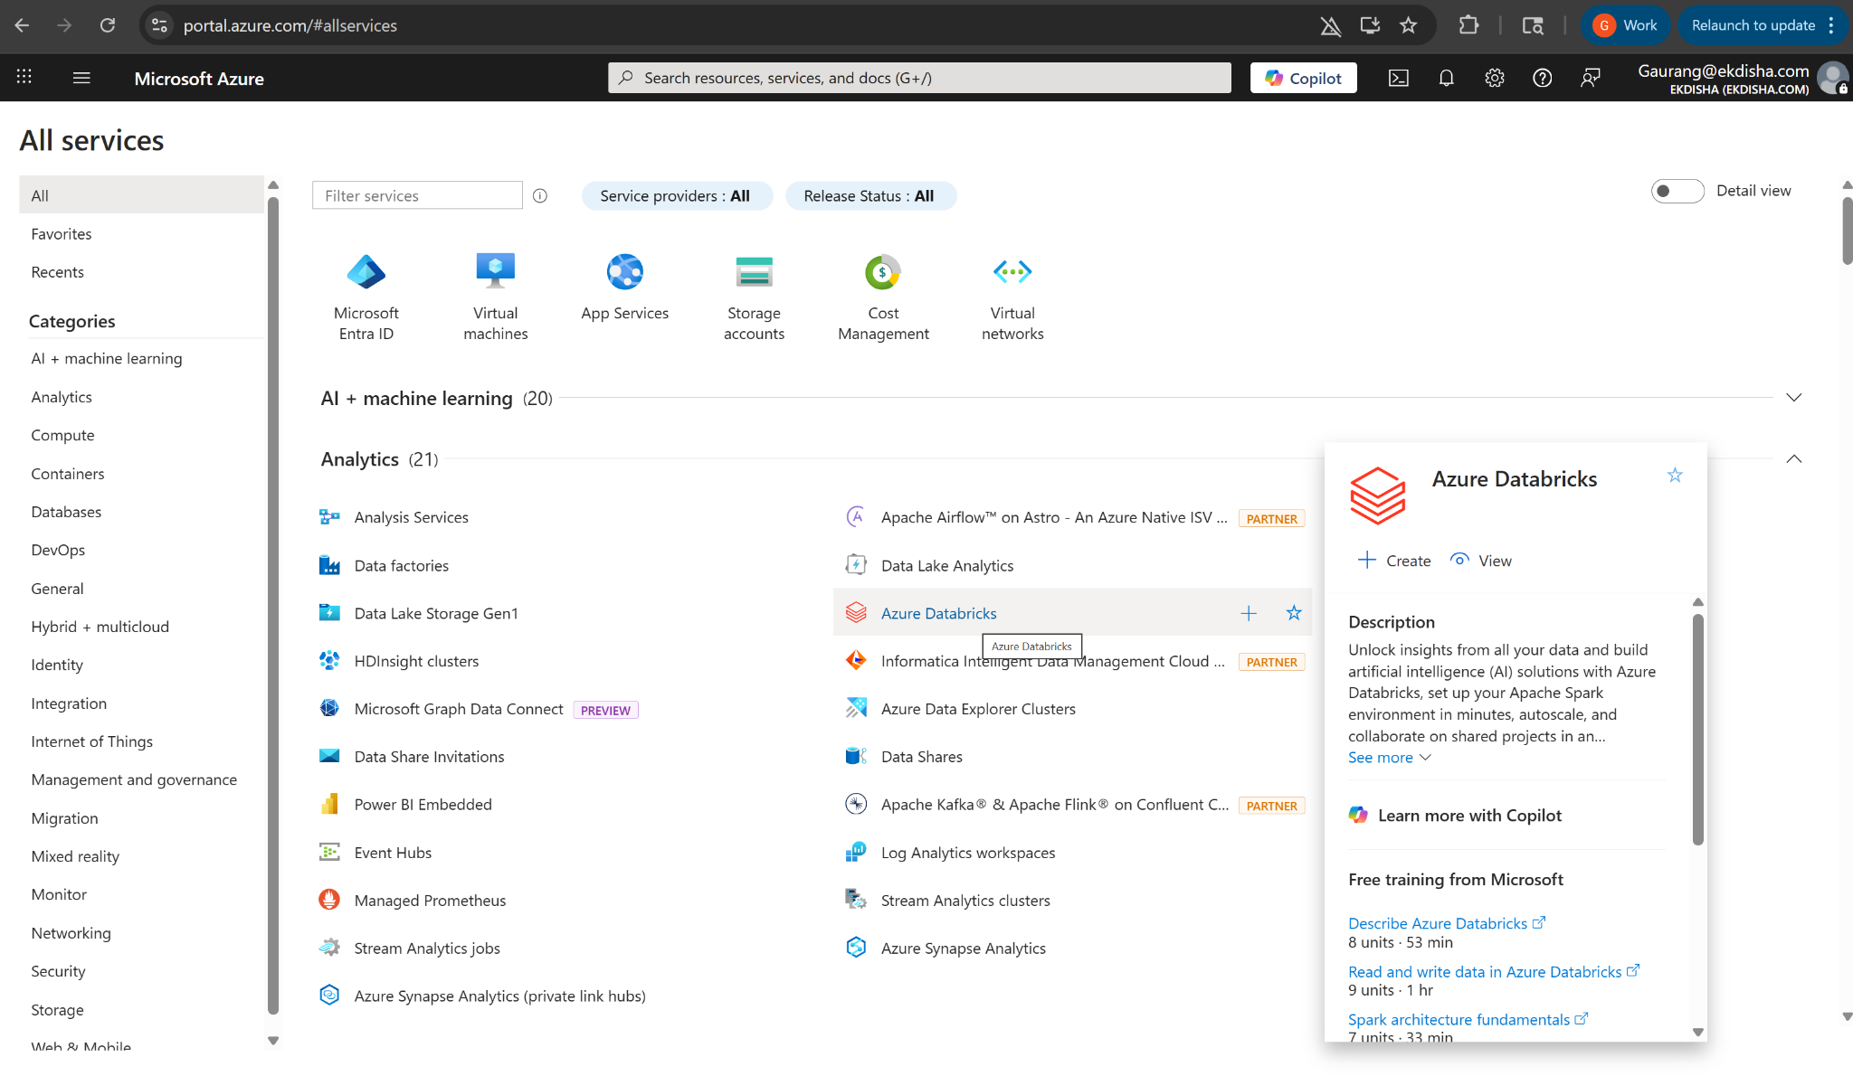

Customization options example -
